## Lesson 23 – Orthographic Projection

## Getting Started

**Orthographic** Projection is a way of drawing an 3D object from different directions.

Usually a front, side and plan view are drawn so that a person looking at the drawing can see all the important sides.

There are two ways of drawing an orthographic projection - **first** and **third angle**.

The design sheets should be labelled using the appropriate symbols to represent which version is being used.

Below is an L shaped object and a representation of the three views used in first angle projection.

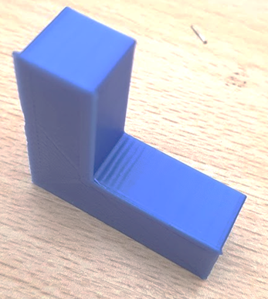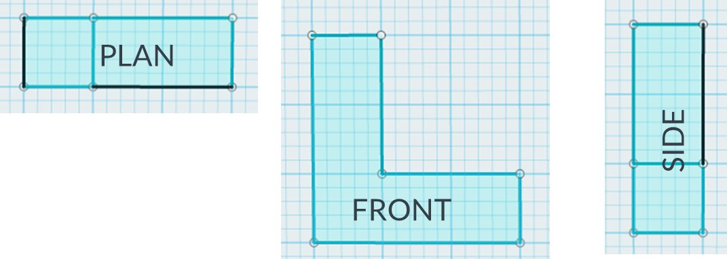

## Success Criteria

* Identify the three views needed for first angle orthographic projection
* Represent a simple/single object using first angle orthographic projection
* Represent a complex part using first angle orthographic projection
* Identify the differences between first angle and third angle orthographic projection

## Pro-tip

* Try to imagine yourself stood in the different positions to visualise each view

## 

## **Using the layout style above complete the following exercises**

1. Draw an H in first angle projection
2. Draw fizzy drinks can in first angle projection
3. Draw a pyramid in first angle projection

## Test Time

The design plan we have used does not include dimension lines.

* Why is this not a problem?
* What is the purpose of the symbol in the bottom left corner of the plan?
* Are you able to represent objects using orthographic projection?

## Stretch Tasks

* Some countries use third angle projection – research the difference and produce one plan using third angle projection
* Explain how orthographic projection helps manufacturers and designers
* Draw the following shape using first angle projection

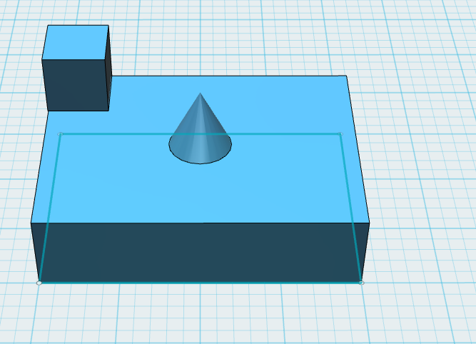

## Final Thoughts

* In this lesson we have looked at the process involved with representing a 3D object as a 2D plan.
* We have used first angle orthographic projection and produced design sheets of simple and more complex shapes.